Overview
Upper Guk is a great dungeon from levels 15-35 or so. The loot isn't the greatest, although Ghoulbane and the ancient croc are two highly prized spawns in the zone. The main problems with this zone are the frequency of trains (which is why it's best to hunt away from the main paths of traffic) as well as the distance from a good bind location. For evil races, this isn't too much of a problem, as grobb is a very short walk away.
The spawn time in guk is about 16.5 minutes, and everything spawns according to this clock. All spawns are standard everquest spawns, except the ancient croc, which has a very odd spawning pattern which I'll discuss in a seperate section. The key to hunting in upper guk is either staying on the move so you don't get backspawned, or finding a good safe spot to pull to and pull monsters to there. Hopefully a safe room out of the way of trains. Pulling singles is very useful, as is staggering spawns her, but with a 16 minute spawn time, you can easily get experience without doing too much far away pulling.
Probably the best groups for upper guk are mostly tank groups that can just chew through the frogs. A cleric helps, and a bard is really nice to have. Plus you need some way to stop runners. Casters aren't nearly as important due to the lack of dangerous casting frogs.

Monsters
Frogloks in guk have a very specific naming convention which can easily help you determine levels/difficulty. There are basically three types of frogloks besides the named ones: warriors, shamans, and knights.
- Warriors are the standard froglok type, and are basically your standard warrior monster.
- Shamans are shaman types of mobs. They go down quick, but they can cast spririt of the wolf and healing which is very annoying. They can also root. They are very fond of casting drowsy/walking sleep which slows down your attack rate. It's best to kill shamans before warriors. Typically 1 or 2 levels lower than their warrior counterparts.
- Knights are just like warriors, except typically 2 or 3 levels higher, and they seem to have higher ac and strength than the standard warrior type of monsters.
Additionally, there are different clans of frogloks, which range from level 14 to level 47. In upper guk, they go up to level 31.
- Wimps - Sentrys, guards, sentinels, neophytes and tads all range from 1-12. They drop netted and woven.
- Tuk - These range from about 12-16, and are the weakest kind. They drop woven armor and can be found mostly in the entry area of guk
- Gaz - These range from 16-20, and drop mesh armor. They are a little distance from the entry, and are relatively easy to pull to the zone.
- Ton - These range from 19-24. They are found over most of upper guk, on the bottom floor.
- Vis - These are the shaman counterparts to Ton. There are very few seen in guk.
- Shin - These range from 25-31, with the knights only being found near the entrance to lower guk live side. The knights are also found in lower guk. This clan is in charge of upper guk
- Nok - The shaman counterparts to the Shin warriors.
- Tsu - Very rare to see one of these in upper guk, they are the shaman counterparts to the Wan knights in lower guk.
Given these level ranges, you can easily pick an area of guk to hunt in depending on your levels. Killing massive amounts of low blues is by far the best way to get experience.
Some of the other mobs in guk are Heart Spiders (poisonous, non aggro, social, around level 15), Swampwater crocs (non aggro, around level 10), and Fungus men, which i know very little about since there are so few of them.
Someone mailed me some information on the Fungus Men (man, aren't they Fun Guys?): In the fungus farm, there are:
- Fungus Soldier - weak melee critter
- Fungus Breeder - druid type, casts stinging swarm, which is no joke if you're trying to solo it
- Fungus Ancient - I haven't gotten it to spawn yet, just heard them casting a few times.
- Fungus Drones - will heal any fungus in range, so unless you can unload HARD its best to pull targets away from the room.

Map and Breakdown of Upper Guk
By far the best map of Upper Guk is Quester of Norrath's. However, it is missing an area, which I filled in with eq'lizer's map.
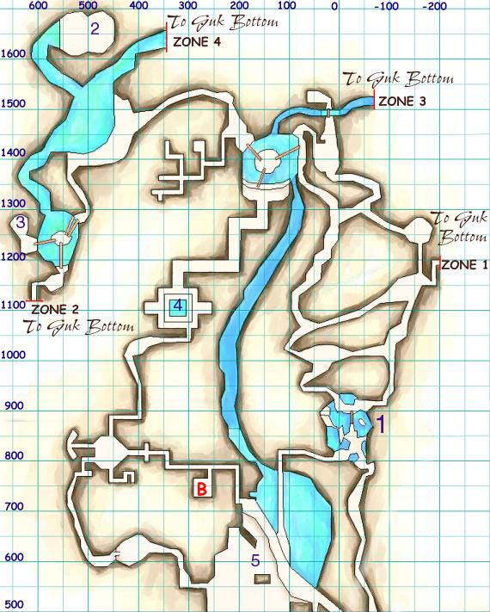
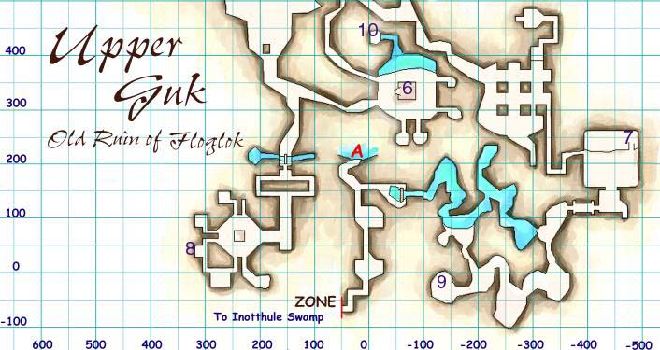
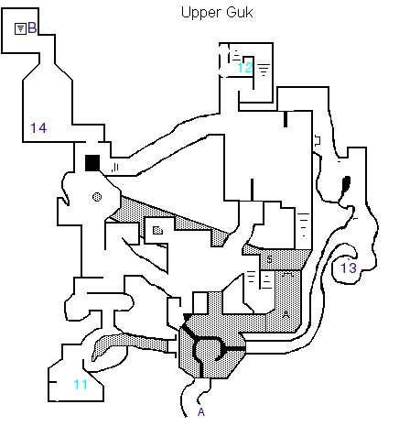
(The bottom map connects to the top map by passages "A" and "B")

- Heart Spider Bridge - Probably the least known spawn in Upper Guk is here. This area is known as the heart spider bridge, as it is covered with heart spiders. If you fall off the bridge, you have to swim around until you find the ladder leading back up to the bridge. Under the water here is a secret room that you can swim to. In this room spawns Tempus, a Dark Elf Necromancer, as well as the skeletel monk. No one knows what tempus is for, but he drops nothing and talks to no one. The skeletel monk is for some classes's armor quest.
- The Ancient Croc Room - The most social area in upper guk. If the zone is completely empty, chances are you'll still find someone sitting in here killing the crocs. It's also a common bind point for casters that are hunting in lower guk. This room is completely safe and out of the way of trains. It is a very good place to med up. The room spawns either 1 saltwater croc, 3 saltwater crocs, 5 saltwater crocs, or 1 ancient croc. The ancient croc drops 50/50 gatorscale leggings/gatorscale arms. He's a pretty rare spawn, showing up about 15-20% of the time. The saltwater crocs are about 29-31, and the ancient is 31 or 32. They hit hard for their level, but have very low AC. In order to trigger the respawn, all saltwaters must be killed. Saltwaters also drop the Rune of Scale for some wizard or necro quest.
- Nokta Shaman Room - A new spawn in upper guk, the nokta shaman spawns in this room (There is also a Shinta Warrior and a Tonta Knight, but I don't know where they are). The Nokta spawns 80% of the time, and has the globe of fear for a necro quest about 25% of the time. The nokta shaman is exactly like a Nok shaman.
- Froglok Summoner Room - This room spawns up to two froglok summoners near the benches on the sides of this room. About 5 frogs spawn total in here, so it's not an easy room. Froglok summoners are magicians, and they drop a Brazier of Elemental Summoning, which has one charge of the level 20 (?) fire elemental spell. There is also a priest that sometimes spawns in this room that drops a enchanter only rod of some sort, probably for an enchanter quest.
- Fungus Farm - This area is called the fungus farm, and is where all the fungi spawn. They drops some one use charge item, maybe a shield of thorns or something silly like that. They make funny sounds when you hit them, but they all have a built in damage shield which makes them annoying as hell to kill for melee classes.
- Froglok Prison - This room is called the prison, as you can find some troll prisoners in the cells here. There is also a tower in the middle of the room. This room is where the Froglok Warden spawns. He's about level 25-27, and drops the Elf Hide Gloves (common) and the Troll Hide Belt (rare). It's assumed that the elf hide gloves are made from dark elf hide, since frogloks are friendly to high elves and wood elves. Heh. The warden is a rare spawn.
- Scryer Temple - This is considered the gateway to the second floor of lower guk. The room looks like a large temple with a little pool of water in the middle, and two columns of water. The scryer spawns on top of the stairs here in the rightmost spot. He drops the bracelets of woven grass (common) and the shimmering orb (rare). He also drops a mask for an enchanter quest. In one of the water columns drops an icon for a cleric armor quest. Scryer is a rare spawn.
- Shin Lord/Barracks - Probably the most dangerous area of upper guk, this room is basically a small cluster of many shin and ton knights. It also spawns the Froglok Shin Lord, who drops Ghoulbane (rare) and Silver Plated Bracers (common). Beware in pulling the room next to the Shin Lord room. There's an invisible wall there that the Shin Lord can see and walk through, making a nice 6 or 7 mob fight if you're not careful. The shin lord is a rare spawn.
- Large/Giant Heart Spider Room - This whole area is called the heart spider room, and is full of heart spiders. It's a very safe area to pull to. In the spot marked on the map spawns 3 heart spiders. The middle one can sometimes be a large or giant heart spider. The giant heart spider drops the chittin shield (common) and the chittin tunic (rare). The giant spider is a rare spawn.
- Safe Prison Room - Swimming under the water here and back up will lead you to a tiny room that seemingly has no purpose. This room is completely safe and is a good place to med/rest. If your swimming is good, you can pull to here too.
- Froglok Necromancer - One of the low level mobs here, the froglok necromancer drops the pouch of ghoul ashes, which has some useless effect.
- Froglok Idealist - Another low level spawn, the idealist drops a vial of egg whites (common), and a moss mask (rare). Both these items give enduring breath. The tonta knight also spawns here.
- Froglok Realist - I guess this guy is supposed to be diametrically opposed to the idealist. His rare drop is the Reed Ring, and I've gotten conflicting reports as to whether his common is the pouch of ghoul ashes or if the necromancer drops that.
- Gaz Squire - One of the few low level mobs here worth hunting. He's about a 20% rare spawn, and drops the collar of undead protection (common), and the runed bone fork (rare). He's about level 17.

Suggested Hunting
- Levels 1-15. Probably stay near the entry zone and hunt pull the weenie frogs. Be careful on the C bridge, it can be hard ot navigate, and falling off can be a major pain.
- Levels 15-20. Either hunt in the same area and pull gaz from near the idealist room. Or hunt near the heart spiders and pull from the scryer room.
- Levels 20-25. Hunt near the froglok warden or near the dead zone to lower guk. The danger of hunting near lower guk zone is that people will occassionally train stuff to there while running to lower guk
- Levels 25-30. Now you can either hunt the barracks and do the shin lord with a good group, or move to near the saltwater/ancient croc and do tons and shin warriors. The ancient croc room is nice because there is a zone right by there which is very safe since there's never anything on the other side.
- Levels 30-35. The only place left to hunt are the shins and nok by the live side of lower guk. Ancient room is good for this, as well as right by the live zone. At 34-35 the dungeon starts greening out, and in a large group you'll probably have trouble finding blues to hunt. Time to move to lower guk.

