Overview
Solusek's Eye, also referrred to as Solusek A or SolA, is one of the most underutilized dungeons in the game. It's one of the bigger dungeons, with a ton of great xp and items to be found. One of the biggest problems with the dungeon, however, is that usually the level range that it is targeted at does not come here. Most of the time because high levels (45-50) are usually camping many of the named monsters which drop the best items in the dungeon. Many of the items in this dungeon are some of the best non-planar non-dragon items in the game.
Unfortunately, I did not start doing this dungeon for experience until about level 38, so I don't know as much as I should about killing the fire goblins, etc, for experience. I'll try to relate what I do know however. The zone can be accessed through either Solusek B (Nagafen's Lair) or Lavastorm. There is one entrance from lavastorm and four entrances from Sol B. Any of these zones except the lavastorm entrance is a good place to fight in case your party needs to make a quick exit.
There are two things in this dungeon that most people are turned off by: Lava and Large Races. There are quite a few places in the zone that have lava, which can be dangerous, taking off lots of life very quickly, and making corpse recovery very difficult. I personally have never fallen in the lava once. Perhaps this is mostly my good fortune, but almost everyone I know that's hunted in Solusek A has never complained about falling into the lava. There are many places to fight in Solusek A that are nowhere near lava. Still, it is a danger you should be aware of.
The other problem is that many of the corridors are too small for the large races to pass through. My only advice here is to use the Shrink spell, or don't come here with a large race character. You will find it very hard to fight if you can't reduce your size.
The monsters here range from the Young Goblins at level 20, up to the Clockwork Guardians and named gnomes who can reach level 34. The rare lava elemental is around 38. You can get good experience hunting here up to level 45.
Solusek's Eye can basically be divided into three major sections. The first section, the entry area, is mostly goblins, with some other monsters thrown in, and a few gnomes. This is what I call the entry zone, even though it is a huge area. To the south is the Goblin Castle, which has lots of goblins, including some of the higher level ones (Inferno and Solusek goblins). To the east is the Gnome Castle, which houses the Solusek Mining Company, its clockwork guardians, and a rare lava elemental friend of theirs. Both of the castles have a merchant in them, making it quite easy to get rid of loot.
The spawn time on the entire dungeon is around 20 minutes, but alot of spawns will skip a round for some unknown reason (much like permafrost). I've seen two hours go by where a certain spot hasn't spawned once. Some people claim that certain spawns have to be killed in order to trigger the next one to spawn, but I've seen no evidence of this.

Monsters
There are basically two main inhabitants of Solusek's Eye: Goblins and Gnomes. They are not hostile to each other, but the goblins are hostile to most all players, and the gnomes are hostile to evil races. Both inhabitants have faction hits and bonuses for killing them. The goblins are opposed to the Fire Giants, and I believe Lord Nagafen (there's a room with a mural showing the goblin's plans for attacking the dragon :). Killing them will hurt goblin faction, and raise fire giant faction. The gnomes are from Ak'anon, but even if you are KOS in Ak'anon, you might not be KOS here. Killing gnomes will hurt your Ak'anon factions however, and killing Kobolds in Solusek B will raise your faction with the Solusek Mining Company.
Goblins
There are six "clans" of goblins in Solusek, as well as three different classes. The clan can help you determine the level or difficulty of the goblins, and the classes determine their capabilities.
- Regular goblins are typically warrior class, although the young goblins are rogues, so be careful when running from them, they can backstab.
- Wizards are standard wizard type monsters, and although they have low hit points, they can reduce your hitpoints quickly. Too many wizards can make it hard to feign death as well. Wizards can see invis.
- Shaman are shaman monsters, and can toss some weaker heals and buff other goblins as well. They can also cast spirit of the wolf, making the monsters run away faster. Shamans can see invis.
The six clans are as follows. Note that the level ranges I have given might be incorrect, they are only a estimate. If anyone has the correct levels for these clans, please let me know.
- Young goblins are the weakest clan, are around level 19-21. They can mostly be found right around the lavastorm entrance.
- Cinder goblins range from 21-23, and are found in the entry area.
- Flame goblins go from 23-25, and mostly inhabit the north area near the goblin captain, with some in the castle.
- Fire goblins are 25-27, and are the toughest goblins found in the entry area. Most can also be found in the goblin castle. They also drop the Fire Goblin Totem, which is needed for the crafted helmet quest.
- Inferno goblins, 27-30. They are found in the goblin castle, around the torturer, and rarely outside. The Inferno Goblin Wizards also drop the Heart of Fire, which is needed for a wizard quest as well as ranger ivy sleeves.
- Solusek goblins are the toughest, around 29-31. They are a little weaker than Shin Knights from Guk, and are guards in the goblin castle. They also have champions. They can be found near the king and high shaman. Champions drop Fiery Vambraces, which are needed for bard Lambent Sleeves quest. Firewalker boots, for bard Lambent boots quest drop on Solusek Mages.
Gnomes
There are two basic types of monsters in the gnome areas. The gnomes themselves, including Miners, Curators, and Conjurers. And the clockwork guardians (prefix: CWG), which have 3 types and 3 levels of difficulty.
- Miners are typical warrior mobs, ranging from level 29-33 or so. They seem to have low str and ac, making them pretty easy kills for their level.
- Curators are cleric monsters, ranging from 30-33 or so (I have yet to see one cast Superior Heal). They aren't too difficult, but annoying because they are clerics. Even if you are amiable, they will heal any gnomes you are fighting, although they won't actually join the fight.
- Conjurers are magician monsters. This means they almost always have a pet and a damage shield. If you plan to melee them, make sure you bring something to dispel their damage shield. They also nuke a little hard. And they have an annoying habit of damage shielding any gnomes that are near them or pass by them.
The clockwork guardians are called "CWG Model xx" where xx is two letters. The first letter determines the difficulty and the second letter determines the special abilities. All clockwork guardians can see invis. For difficulty:
- C is the easiest, usually level 28-30.
- M is the medium, 30-32.
- X is the hardest, 32-34.
The CWGs can also have a special ability. You can determine this ability by the second letter:
- A is a regular warrior, no special abilities.
- B has a force module, which knocks you way back when you get hit. Mostly dangerous around lava, but annoying nonetheless. Always drops either a broken or functional force module, which you can sell to the vendor from 1-3pp.
- C has a frost module, which procs a weak cold based dd spell when it hits you. Not that much damage compared to a regular hit though. Always drops either a broken or functional force module, which sells to the vendor for 1-3pp.
Other notable monsters, besides the named ones, in this dungeon include blazing elementals and a CWG Spider. Named monsters include a kobold, an efreeti, a lava elemental, some named gnomes and goblins, an imp, and a drake. Because of the sheer number of monsters that can see invis, it is suggested that you be careful when travelling through this dungeon.

Map and Breakdown of Solusek's Eye
The best maps of Solusek A are Quester of Norrath's. Not only are the extremely accurate, but they look nice too. Everlore has a nice map as well. You might want to check it out. Unfortunately, he used numbers to mark connection points between the maps, so I've used red colored letters to show detail areas for below. The blue numbers are connection points. Sorry for the confusion.
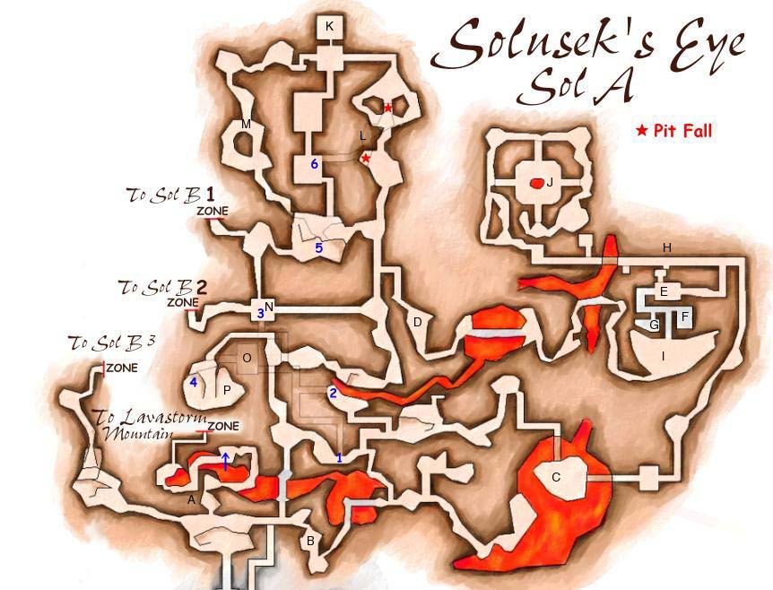
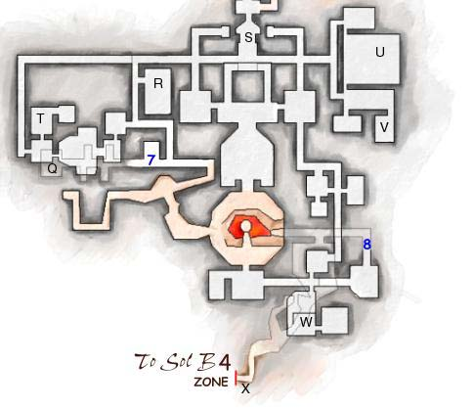
Detail Maps:
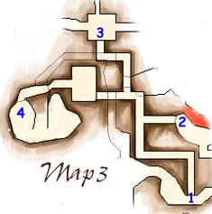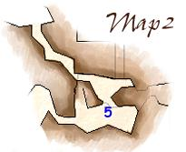
- Window Room - This is the first room that you will come to when entering Solusek through the main entrance. If you aren't a large race, you can bypass most of the initial lava walkway here by ducking and going through the window. Large races get screwed here and have to go all the way around. Mostly young goblins up to this point.
- Gnome Area - This is the start of the gnome area, and you'll see a few clockworks starting at this point. Following this path will take you to the back door of the gnome castle.
- Gnome Castle Backdoor - Briefly swimming in the lava here will take you to an island with two drawbridges. The right one will take you to the gnome castle through a few gnomes (most of which are nice single pulls). Be careful in this area, as many gnomes seem to get caught up near the tip of the lava penninsula, and sometimes there will be 3 or 4 gnomes in one spot.
- Gnome Area - This area, guarded by two gnome CWGs, is the other division between the gnome and goblin areas. Just past the two guard gnomes is where the CWG Model EXG wanders to.
- Gnome Castle Inner Courtyard - This room has a secret wall on the north side which has a switch which will open the back door of the gnome castle. It's a great room to pull to, as its outside the aggro range of all nearby gnomes. Only one wanderer comes through it. While there are gnomes above the courtyard on the upper floor, they will not heal or assist gnomes that you are fighting in the courtyard.
- Gabbie's Room - Gabbie Mardoddle (The architect? of the Solusek Mining Company) spawns here, along with two other CWGs. She's one of the most camped monsters in Sol A. She only spawns about 20% of the time. Her common drop is the pet weapon, the Mithril Quill, which is mostly useful for selling to the vendor across the hall for 2pp. Her rare drop, however, is the excellent Molten Cloak, one of the best backwear for casters and priest classes. She's around a level 33-34 wizard.
- Marfen's Room - The gnome vendor spawns here, his name is Marfen something or the other. Another CWG spawns in the room as well. He sells the Tinkerer's Pack (100% weight reduction, all size, 8 slots, 2.0 weight), and is useful to sell all the stuff you've taken off his dead gnome friends. I killed him once for fun, and like most vendors, his body disappeared. Ugh. It's interesting to note that Marfen is on a difference faction that Solusek Mining Company (probably Ak'anon merchants).
- Castle Upper Level - The door here leads to the upper level of the castle, which unfortunately, is not mapped. It's a small area, with a few regular gnome and CWG spawns. In the room across from the door, there are three spawns. The one in the corner is a placeholder for Captain Bipnupple, a 20% rare spawn. He's the leader of the Solusek Mining Company, and drops a Brick of Blue Ore (which theoretically is used for the as-of-yet-unsolved Blued Two Handed Hammer quest), and the Gnomish Environment Suit (which is mostly used for dragon runs). Mostly he's camped by people camping Gabbie who are too bored of sitting in that room all day. Capt Bipnupple is around level 34. From the upper level, you can quickly drop down into the inner courtyard (E) or to the outer courtyard (I).
- Gnome Castle Outer Courtyard - This is the main entrance to the gnome castle. The CWG Model EXG and his placeholder spawn here and wander back and forth between here and (D). The EXG is 100% immune to magic, but otherwise like any other standard level 30ish monster. He drops the great Charred Guardian Shield, common, and the mostly-for-show Charred Guardian Breastplate (rare).
- Lava Elemental Room - I call this entire area the "Museum", mostly cause there are usually lots of curators around (Ha Ha). It's the main mining area for the gnomes. Secret walls on all four sides of the central area open up into a room with a pillar of lava in the middle. There are five spawns in here, 4 CWGs, and a wanderer. The wanderer is either a CWG or 20% of the time, the Lava Elemental, the highest level monster in Solusek A. The lava elemental usually drops a potion which casts a damage shield on you. His rare drop is the Runed Lava Pendant (AC 5, STR 6, low weight), a great neck piece. The elemental usually has a nasty damage shield on him, and is around level 38. Beware that even if your gnome faction is good, the gnomes will assist the elemental unless the gnomes are much lower level than you. This is much like the huge elemental in lower guk. They will assist even if the elemental attacks you. I've been informed that if you swim down the lava tube in this room, you can get to another room. There's also a lava tunnel there, but as far as I know, no one has ventured any further down it.
- Fire Goblin Captain Room - The Fire Goblin captain spawns here. Not quite sure on his level or rarity, but I'd guess mid twenties. His common drop is Charred Boots, and his rare is Charred Gloves. Most people would only bother with this stuff if you want a complete set of charred goods :).
- Pit Trap/Reckless Efreeti - A pit trap here drops down into a room with three blazing elementals. They aren't very high level, but have a nasty damage shield on them. One of the elementals is a placeholder for the reckless efreeti, one of the coolest looking monsters in the game. He drops the Platinum Armbands (common), and Obsidian Flamberge (nodrop rare). The efreeti is mid twenties. The exit and another entrance to this room is through a secret wall at the top of the stairs. If you don't feel like fighting the blazing elementals, run them back to the gnome guards and they'll kill em for you. If you just enter the secret wall, two of the blazing elementals will immediately attack you, but the last Efreeti or placeholder will not attack you.
- Kindle - Kindle, the oh-so-annoyingly rare imp spawns here and wanders around in a circle. He's mid twenties, and drops the Obsidian Ring (common), and the precious Impskin Gloves (rare). His placeholder is the wandering goblin in this area.
- Singe Spawn - The rare spawn Singe, a named fire drake, spawns here and wanders around in a circle. His placeholder is a wandering goblin. His common drop is Obsidian Bead Hoops, and his rare is the Drakescale Belt. Heis level 28.
- Foreman Room - The Goblin Foreman spawns here, mostly just before getting slaughtered by a druid. He drops the Foreman Tunic (common), and the Obsidian Scimitar (rare). Pretty good area to hunt in due to the close proximity of escape zones..
- Predator Room - The only kobold in the zone, I guess he hopped over from Solusek B to kill a few goblins? He's mid twenties, and drops Kobold Hide Boots (common, does he really wear his own skin as boots?) and the Obsidian Shard (decent piercing weapon, rare). Note that the spot marked on the map is slightly off. The Predator spawns behind the door at the top of the stairs.
- Inferno Goblin Torturer - Starting with this point, I know very little about the area except what I've gleaned from others. I spent very little time in the goblin castle. The torturer spawns here, past all the cells. His common drop is the Turqoise Eyepatch, and his rare is the weight reducing memento box (weight reducer, small size only).
- Goblin Merchant - This room spawns the goblin merchant, who will buy and sell stuff. I think he even has food. You are probably KOS to him, but using sneak you can still buy and sell stuff from him.
- Goblin Castle Entrance- This area is the entrance to the goblin castle. Hardly anyone goes to the goblin castle. It's an interesting place to visit, with lots of uncamped named spawns.
- Fire Goblin King- The Fire Goblin King, about level 30 or a little higher, spawns here. He drops the Ring of the Goblin Lords (common), and the Sceptre of Flame (rare). Not to be confused with the Staff of Fire. Just before the king room, you will find the throne room. This room spawns Solusek goblins, mostly Champions and Mages, and occassionally priests.
- Goblin Bar - The Fire Goblin Bartender spawns here, and alot of monks like to solo behind the bar. He drops the Drake Hide Sleeves (rare), and the Drake Hide Leggings (common). He's mid twenties.
- Drunkard Room - The Fire Goblin Drunkard spawns here. It's funny thinking of a drunk goblin. Regardless, he drops the Staff of Fire (rare) and the Frothy Goblin Tonic (common). The Frothy Tonic is one of the few instant healing potions in the game. I think it heals about 80 hps? Maybe more. I think he also drops the Fire Goblin Totem (which can actually be found off any fire goblin).
- Goblin High Shaman Room- The Fire Goblin High Shaman doesn't actually spawn here. He spawns in the room to the right of here. In this room now spawns a quest NPC, a DE Necro named Lynada the Exiled. She drops the Sparkle Purse, which is a container used for a rogue quest. As for the High Shaman, he usually drops the common Glowing Stone Band, but rarely drops the Platinum Totem (I'm not sure if this is the right item?). If you couldn't guess, he's a shaman. High twenties I believe.
- Bats/Bugs Zone - This seldom used/seldom known about zone to Solusek B leads directly to the Bats/Bugs area of Solusek B. It's a nice place for high levels to hunt on that side, because you have this easy escape available.

Suggested Hunting
- 20-25 - Hunt the entry area for sure. Since you don't have evac yet, I'd suggest hunting at the Sol B zone just northwest of the lavastorm zone. This zone is easy to reach by just going through the window room, heading south, and then hanging a right and following the corridor. You can pull Youngs, Cinders and Fires from here easily, from the castle and entry area.
- 25-30 - I'd still suggest hunting a zone, although I'd recommend the zones over by Singe and the Foreman. You can now kill some of the named monsters, namely Singe, the Foreman, Kindle, the Reckless Efreeti, the Predator. Just make sure you have a decent group if you are going after them. You're probably a little too young to solo here yet.
- 30-35 - Now that you have evac, you can safely move in and fight much better. The goblin castle is a great place to hunt, and you can do the entry area much quicker, with a smaller group. It's possible to fight the gnomes now, but I'd suggest waiting a few more levels. If you wish to solo, the bartender area, or the entry area would be good. Just make sure you have an escape plan.
- 35-40 - You can pretty much do the entire zone in a group now, although you'll only get experience from the goblin castle or the gnome castle. I'd suggest doing the goblin castle in a small group, while a full group can rake in the xp at the gnome castle. Solo, you should be able to do well in the goblin castle, and if you choose to head to the gnome castle, make sure you only take the lower level spawns.
- 40-45 - The gnome castle is the only place you can get good experience, but there are plenty of spawns to keep you occupied. Assuming they aren't camped, Gabbie, Bipnupple, the EXG and the Lava Elemental will all give you good items. Solo is also great here now, especially in the gnome castle. Pull to either courtyard, or the corridor behind the castle.
- 45-50 - Chances are, if you're still here, you don't care much that 60% of the monsters you kill are green, you just want to get some items. Stop camping em and camp something worthwhile in Kedge or something :)
Special thanks to Saania MorningDew for extra information on the zone, as well as many others

