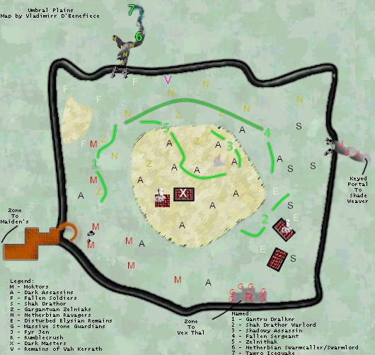
For those that don't know:
RAMPAGE - An attack that hits the top 3 or 4 people on the mob's hate list for an additional round of damage.
FLURRY - An attack that does an additional round of damage to the NPC's current target. If the mob double attacks, flurry hits for 2 more bringing the attack to 4 hits. If the mob quads, flurry hits for 4 more bringing the attack to 8 hits.
ENRAGE - When low on health, an NPC can ENRAGE, which makes it riposte *all* attacks for 10 seconds. If you do not turn off Auto Attack, you die.
And also, everything in this zone now summons. Aggro range has been turned down dramatically. Any mob 57+ is now unmezzable and will also ENRAGE, including all gantru's and soldiers.
*********************************
Gantru Moktor - Spawn near Maiden's Eye zone line. Their HP have been doubled to around 15-20k. Melee-only NPCs, these guys can now range in level from 54 to 58. Drop Umbral gems and rare (1 in 50 ish) Moktor armor. Fire spells hit Moktors more easily than others.
Gantru Raldukan - Spawn near Maiden's Eye zone line - can spawn in any Gantru spawn spot. Their HP have been doubled to around 25-30k. Melee-only NPCs, these guys can now range in level from 58 to 59. Their loot has been upgraded; every time they drop either a Helm of Raldukan, Gantru Charm, or rare (1 in 50 ish) Raldukan armor. If Raldukan armor drops, they will still also drop either a helm or charm. Fire spells hit Raldukans more easily than others.
Gantru Shojen - Spawn near Maiden's Eye zone line - can spawn in any Gantru spawn spot. Their HP have been changed to around 10-50k. Shaman NPCs, these guys can now range in level from 55 to 58. Also can spawn as Shojilens, identical except for a 1 or 2 level difference. Can be mana tapped. Fire spells hit Shojens more easily than others.
Gantru Dralknr - Spawns near Maiden's Eye zone line. This is the named Gantru. His HP is on the order of 50k. He's a melee-only NPC, level 59. Doubles for 200. He ENRAGES. He drops the new bracers: Each has ac 12, +6 to all resists, and +15 to a stat. There is a bracer with +15 to STR, to STA, etc... for each stat except DEX and AGI, which are combined into one bracer. Bracers are ALL/ALL and weight 0.7 Resists most spells except lures.
================
Fallen Soldier - Spawn to the left of the Maiden's Eye zone line. Their HP have been doubled to around 15-20k. Melee-only NPCs, these guys can now range in level from 54 to 58. Drop rare (1 in 50 ish) Dreamweaver armor. Magic spells hit soldiers more easily than others.
Fallen Sergeant - Rare spawn soldier, pops towards the middle of the zone. Level 58 with 30-35k HP, doubles for 180. Slowable. Identical to fighting a soldier, except the HP difference. ENRAGES. Drops a Skull Marked Shield.
================
Dark Assassin - Spawn all over the zone. Unchanged in the recent patch, these are still level 55 undead mobs with about 15k HP, which can backstab for up to 700 and proc Dooming Darkness. Double for 200. They drop rare (1 in 50 ish) Dark Assassin armor. Cannot be mezzed or snared. Ironically, these used to be one of the most feared mobs in the zone - now they are one of the easiest. Just don't pull more than one.
Dark Master - 4 of these spawn in the center of the zone, surrounded by about 15 wandering Dark Assassins. They have been upgraded to level 60. Harm touch for 1001, and have on the order of 75k HP. They cast Engulfing Darkness as well as Fear and Fear2 and a 45 point lifetap. Double for 200. They RAMPAGE very frequently. Cannot be mezzed, snared, rooted, stunned, or slowed. Drop rare (1 in 50) Dark Master armor. Can be mana tapped. Can only be hit with Lure spells.
Shadowy Assassin - The rare spawn assassin. Doubles for 200, FLURRIES and RAMPAGES (and I assume ENRAGES as well). Cannot be slowed. Spawns near the middle of the zone - which is bad he is near many other Assassins. Put the previous three sentences together and you'll be able to figure out why we don't know if he ENRAGES or how much total HP he has. Ouch.
================
Garguantuan Zelniak - These are melee-only horse-dog things that are level 55-57. No known drops.
Zelnithak - Very huge named Zelniak. Level 60, doubles for 400, has an AoE Earthquake stun and an AoE 400 point disease nuke.
================
Netherbian Ravagers - Little yellow aliens. Double for 200, 20k HP'ish. Drop rare Rotting Flesh (INT Caster) armor.
Netherbian Flesheater - Named alien, except he's bigger, and white. Level 58. Similar fight to a Netherbian Ravager; he is slowable and doubles for 200. Spawns in the Netherbian cave, down the left-hand path.
Netherbian Swarmcaller - Named alien, except he's bigger, and purple. Level 58. Similar fight to a Netherbian Ravager; he is slowable and doubles for 200. Drops nothing.
Netherbian Hive Fiend - Named alien, except he's bigger, and white. Level 58. Upon entry into the Swarmcaller's room, 3 ravagers will pop. Upon their death, 3 more, plus the hive fiend, spawn.
Netherbian Swarmlord - Named alien, looks just like the Swarmcaller. Level 60. Spawns a half hour after the Swarmcaller's death; despawns 15 minutes later.
Tawro Icequake - Named blue alien, deep in the Netherbian cave. Level 60. Hits for 350, has about 80k HP. ENRAGES. Drops nothing.
Spirit of Tawro - Named blue elemental, spawns upon the death of Tawro. Level 60. Level 60. Hits for 350, has about 80k HP. ENRAGES. Drops some of the best loot in the game.
================
Shak Drathor - Little black alien guys (melee-only) that now range from level 55-57. They double for 150, and have around 15k HP. They drop Dreamweaver armor. Spawn past the temple, near the burnt out houses.
Shak Drathor Warlord - Named little black alien guy that is level 59. Doubles for 200, cannot be slowed, snared, or rooted. Around 50k HP. Is completely resistant to taunt - only melee damage, nukes, or heals get his attention. Runs when low on health. Drops an AC 3, 3 WIS, 3 INT head piece
================
Disturbed Elysian Remains - These have been upgraded as well, to about 20k HP a piece. Level 54-57. They drop Elysian (Druid) armor, whose drop rates have skyrocketed. One drop around every four kills.
Corrupted Elysian Remains - Rare spawn elysians. About 30k HP a piece. Level 57-59. They are rumored to drop WIS caster armor.
================
Massive Stone Guardians - Melee only mobs that double for 300, cannot be mezzed. These surround the temple. Drop nothing.
Rumblecrush - Previously slaughtered by OWD, he used to double for 370 and have around 75k HP. But he had no drops. Well, he now drops things; nice things... Oh, did I mention that his HP was doubled and he double attacks for 700 (plus RAMPAGE, FLURRY, and ENRAGE)?

