Orb of Mastery Quest

Note : If you have turned in the the items to obtain the Power of Wind before you are ready to complete the quest you can spawn the Master of Elements by saying the phrase "I want to see the master." to Kihun Solstin in the plane of Sky quest room.

Lake Rathtear
Your Location is 967.70, -665.27
You say, 'hail Rykas'
Rykas says 'Greetings Ronaldor , I am Rykas, chronicler of knowledge. I have journeyed all throughout the lands of Norrath, and I have learned many tales of adventure from people I have encountered during my travels. I have learned of legends known and unknown to most mortals. Are you in search of knowledge?
You say, 'I am in search of knowledge'
Rykas says 'A small task is needed if you wish to learn more. Do you wish to learn the tale of Magi'kot?
You say, 'I wish to learn of the tale of Magi'kot'
Rykas says 'If you seek to learn the tale of Trilith Magi'kot, your journey shall begin in the Commonlands. Search for Jahsohn Ak'sot and give him this token. He will share some of the knowledge I have bestowed upon him, and point you further down your path to Mastery. Bring me the Words of Mastery, Power of the Elements, and the Words of Magi'kot....Then you shall learn more about the power of the orb.
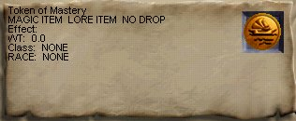
Rykas gives you a Token of Mastery take this to Jahsohn Aksot in the Western Commonlands.
Western Commonlands
Your Location is 62.78, 3639.68
He will walk between these two locations.
Your Location is 957.12, 3470.47
You say, 'hail Jahsohn Aksot'
Jahsohn Aksot says 'Greetings, Ronaldor .
Jahsohn Aksot says 'What is this? I cannot believe you found it! Where did you get this?
You gain experience!!
You say, 'Rykas gave it to me.'
Jahsohn Aksot says 'I have not heard of anyone speaking that name out loud in years. Rykas once shared a tale with me, though I have lived with fear in my mind ever since. He told me afterwards that I did not have the balance I thought I had. Have you come for the Words of Magi'kot?
You say, 'Yes I have come for the words of Magi'kot.'
Jahsohn Aksot says 'The Words of Magi'kot can only be shared with those elementalists whose minds are of balance. The Words were separated into three pieces by a high council of Magi who feared that the story would bring an end to elementalists throughout Norrath. If you feel you wish to read from the sacred Power of the Orb then an elementalis of such power should easily accomplish this task.
You say, 'What task.'

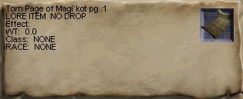

Enraged Dread Wolf (Common) Dread Wolf (Uncommon), Kithicor's Woods
(Only at night)

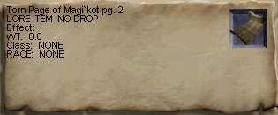

Tentacle Terror, The Estate of Unrest

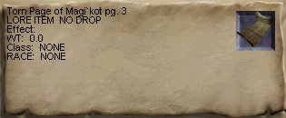

Bloodthirsty Ghoul, Lower Guk
Jahsohn Aksot says 'Bring me the torn pages of Magi'kot. The first section can be found in the depths of a tainted forest, warded by an angry lupine. It is also rumored that one section is found in the haunted estate of a murderer, on a many armed creature. The last may be found in the belly of an amphibian who thirsts for blood.
Jahsohn Aksot says 'Have you forgotten something, Ronaldor ?
Jahsohn Aksot says 'Have you forgotten something, Ronaldor ?
Jahsohn Aksot says 'Rykas may have been right about you, Ronaldor . Now, go find Walnan. Walnan was apprenticed to a very powerful Mage. After her apprenticeship was complete, she wished to begin teaching other beings of Norrath. Even those who knew nothing of the art! I do not believe she was successful, though. Seek her out to further your tale. Good luck in your journeys, Ronaldor !

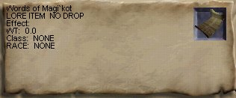
The Butcherblock Mountains
Your Location is 1848.84, 624.28
Walnan is a rare spawn and is not always about, be patient.
You say, 'hail Walnan'
Walnan says 'Hello Ronaldor! I am Walnan, elementalist, summoner, wanderer, and sometimes teacher. Might you be a elementalist in search of the truth?
You say, 'I am in search of the truth'
Walnan says 'The truth is something not all people can handle or understand. If the truth of the elements is what you seek then the Power of the Elements shall reveal all. Have you come to learn of Magi'kot?
You say, 'I have come to learn of Magi'
Walnan says 'Magi'kot was the most powerful elementalist of his age. He may have been the most powerful mortal mage of all time, such was his mastery. He wished to obtain infinite knowledge and wisdom in order to further expand the arcane art of Summoning. Do you know what became of Magi'kot?
You say, 'No'

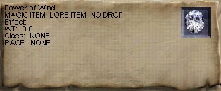

Gypsy Dancers, Castle Mistmoore

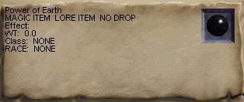

Fairy Guards, The Lesser Faydark

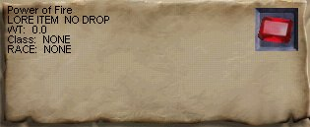

Blazing Elementals and Lava Elementals, Solusek's Eye

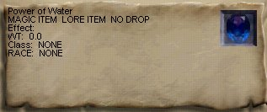

Famished Ravener and Enraged Raveners, Kaesora

Walnan says 'Only a few elementalists and followers outside our circle know what truly happened to Magi'kot. Even now, many are fearful to speak of his name. If you truly wish to continue, here is what you must do. Gather the Power of the Earth, warded by a fae creature. Then seek the Power of Fire, held by an elemental. Next you will need the Power of Wind, held by a twirling and prancing wanderer who has been corrupted. Finally, the Power of Water, held by a ravenous beast who is the minion of a fallen Sarnak. Bring them all to me, and I shall give you the Power of the Elements.
Walnan says 'Wait, Ronaldor, are you not forgetting something?
Walnan says 'Wait, Ronaldor, are you not forgetting something?
Walnan says 'Wait, Ronaldor, are you not forgetting something?
Walnan says 'The arcane art of Summoning is derived from the power of the elements which surround us. Continue your journey across the Ocean of Tears. In a dark fortress, you should find Akksstaf lurking about. Be wary, but tell him that you seek Magi'kot. Hurry now Ronaldor , you do not wish to miss the ship!
Walnan then disappeared from this location.
You gain experience!!
You gain party experience!!

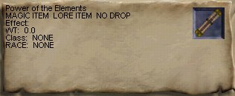

Najena
You say, 'hail Akksstaff'
Akksstaff says 'What do you want?! Foolish Human, I am in no mood to treat with beggars. I have half a mind to turn Jobober here loose on you! Well, don't keep me waiting, state your business or be off with you!
You say, 'Tell me about Magi'kot.'
You say, 'Tell me about Magi'
Akksstaff says 'Ah, that I can help you with. Magi'kot was a powerful elementalist, able to control the power of the elements which surrounded him. He was not able to fully master the elements when I was learning from him, but soon after my departure I heard rumors that he was going after the Orb of Mastery. At the time, I did not feel he was ready to harness all the elements, but Magi'kot listened to no one. He was in search of power beyond any held by a mortal. Do you wish to hear more?
You say, 'Tell me about Magi'
Akksstaff says 'Ah, that I can help you with. Magi'kot was a powerful elementalist, able to control the power of the elements which surrounded him. He was not able to fully master the elements when I was learning from him, but soon after my departure I heard rumours that he was going after the Orb of Mastery. At the time, I did not feel he was ready to harness all the elements, but Magi'kot listened to no one. He was in search of power beyond any held by a mortal. Do you wish to hear more?
You say, 'I wish to hear more'
Akksstaff says 'Then bring me the torn pages of Mastery, there are four pages that can be found upon the women In this keep, though have a care, Najena's followers guard her treasures carefully, and delight in punishing trespassers.

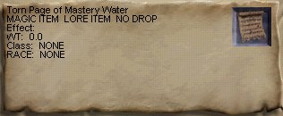

Female Dark Elf Magician, Najena
Alligators, Cazic Thule

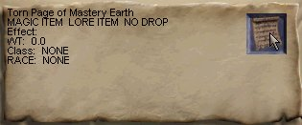

Female Dark Elf Magician, Najena
Alligators, Cazic Thule

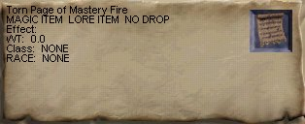

Female Dark Elf Magician, Najena
Alligators, Cazic Thule

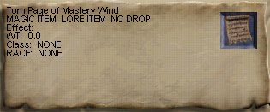

Female Dark Elf Magician, Najena
Alligators, Cazic Thule

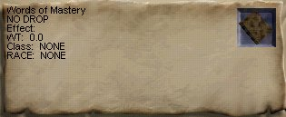

Akksstaff says 'Very well. Take these words back to that shriveled old gnome, Rykas, if you wish to complete this quest. Now leave me, Ronaldor , it sickens me to be this cordial for so long. And Jobober needs exercise. Go!

Lake Rathtear
Your Location is 967.70, -665.27

Note : Now you need to turn in the rewards from the three previous quests to Rykas to obtain the Power of The Orb.

Rykas says 'I see that you have completed the quest I laid before you. That speaks well of your dedication, yet you do not realize your journey has just begun. Study this tome.

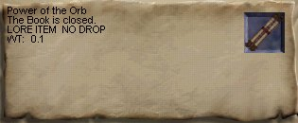

"An Elementalist's power comes from the Orb of Mastery. The Elements of Earth, Fire, Wind, and Water are contained within the Orb. The Master of Elements hold the Orb.

He can be found in the Plane of Air. No mortal has been able to contain the true power of the Orb. Trilith Magi'kot presented himself to the Master of Elements and the Orb of Mastery. The power of elements brought agony to his mind and body. Magi'kot was not of Balance.

Fire burned his eyes unto blindness, Wind put his mind into a spin, Earth entered his body and aged him like the mountains, and finally, Water washed his memories of mortal life away. Failing his test, the Orb exacted its terrible price, and now Magi'kot is part of the Orb.

The bearer of this tome should seek out the Master of Fire and present it to him, for there is much left to be revealed."

You gain experience!!

The Skyfire Mountains
Your Location is 2417.35, 5086.42

Note : Jennus Lyklobar roams the western wall of Skyfire and is not always spawned.
You say, 'hail Jennus Lyklobar'
Jennus Lyklobar says 'Hello and well met, Ronaldor ! Humans like you don't often come here.. Do you come seeking what I possess? Fire, fire, fire and fire is mine! I surround myself with fire, I bathe in fire, I consume fire, I am the Master of Fire! Hahahaha, but I digress. Have you come for the element of Fire, seeking to fall to the same fate as Trilith Magi'kot?
You say, 'I wish to obtain the element of fire'

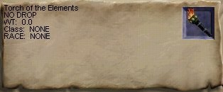
Neh'Ashirr, The City of Mist

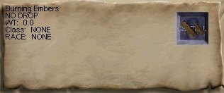
Named Wurms, Burning Woods

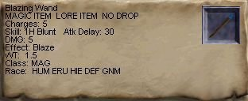
Undertow, Kedge Keep

Rykas, Lake Rathtear
Jennus Lyklobar says 'The Element of Fire I can provide you, but you must prove you are able to contain its power. Bring me the Torch of the Elements now kept by a doomed lord of merchants, the burning embers from a notable member of wurmkind who can be found a short journey from here and a blazing wand, which you should be familiar with. And you must surrender the tome Rykas gave you. But I think you would be happier if you stayed with me and learned more of the beauty of the one true element, FIRE! FIRE! Hahahahahahah!

Jennus Lyklobar says 'I see that you are well versed in the ways of Fire. Indeed, if you are as adept in the other, lesser elements, you may just sieze the Orb of Mastery after all, and avoid Magi'kot's fate. Take this element, and guard it well, for more trials are to come, I assure you. Succeed and you shall be remembered always! Oh, and Ronaldor ? Watch out for the puddles! HAHAHAHAHAHA!
You gain experience!!


Element of Fire
Fironia Vie
You location is (Forgot to do /loc for this one)
Tiblner Milnik says 'Huh? What? Oh, you speak so fast, it took me a moment. I have become used to the slow and stately conversation the Earth holds, where a thought can span aeons. I am the Master of Earth, you know. Though I'm usually too humble to say this, that makes me the most powerful mortal in Norrath, as everyone knows that Earth is the only REAL Element, all else must give way before its power. Water is absorbed by it, Air is ignored by it, and Fire is contained in it. But you know all these things, I am sure. Are you interested in obtaining the Element of Earth? I know Magi'kot was, but we know what happened to him, don't we?
You say, 'I am interested in obtaining the Element of earth'

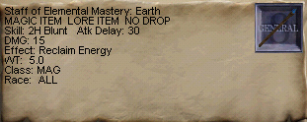
Magi P'tasa, Plane of Hate

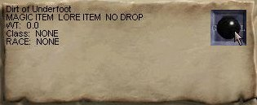
Slixin Klex, Burning Woods

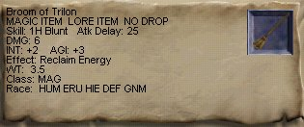
Vira, Temple of Solusek Ro
Quest Item

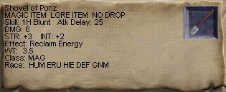
Vira, Temple of Solusek Ro
Quest Item

Tiblner Milnik says 'Combining the following items can bring the Element of Earth together. Obtain the Staff of Elemental Mastery:Earth, held by the minions of the Prince of Hate, The Dirt of Underfoot found on Slix something or the other, and of course, I shall need the Broom of Trilon and the Shovel of Ponz. Bring all these things, and I shall show you what a true Master of Earth can do, and gift you with the Element of Earth.

Element of Earth

Dagnor's Cauldron
Your Location is -447.00, -2044.00
You say, 'hail Jinalis Andir'

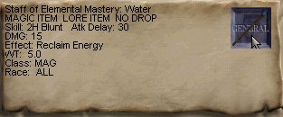
Phinigel Autropos, Kedge Keep

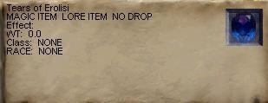

Captian Rottgrime, The Overthere

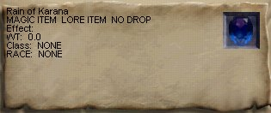

Trabul Earthstrider, Eastern Planes of Karana

Jinalis Andir says 'Let us dispense with pleasantries, Ronaldor . I am Jinalis, as you know. I imagine you want to control the Elements. The Element of Water, which I possess, is the most powerful of the Elements. With it you can control the water which falls from the Air, erodes the Earth, and extinguishes Fire. It is a pity you do not focus on the Prime Element, but if you wish to follow that fool Magi'kot to your doom, I will not stop you. Bring me the Staff of Elemental Mastery:Water held by the last of the Kedge, the Tears of Erolisi held by a dirty and rotten officer across the Blessed Deep, and finally, the Rain of Karana, found on a mighty Giant in, where else, the Karanas.

Jinalis Andir says 'You have the control needed in order to manipulate the water which surrounds us. Take this Element and guard it well, you will need it in the times to come.
You gain party experience!!

Element of Water

Plane of Air
You location is (Forgot to do /loc for this one)
You say, 'hail Kihun Solstin'
Kihun Solstin says 'So, you have made it this far. I am Kihun Solstin, the Master of Wind. I control the unfettered Element like none other. As you should have learned, Air is the most potent of Elements. It fuels Fire, Water is comprised of it, and Earth cannot restrain it. Knowing this, do you seek the Element of Wind?
You say, 'I seek the element of wind'

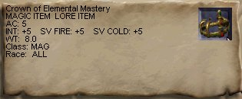
Random Drop, Plane of Sky 7th Island

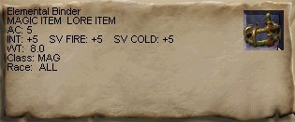
Elemental Warriors, The Hole

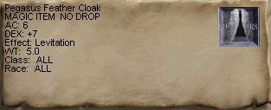
Quillmane, Southern Planes of Karana

Kihun Solstin says 'I will test you then. In this wondrous plane of Air, find the Crown of Elemental Mastery, and search the world below for an Elemental Binder, and a cloak fashioned from the feathers of a Pegusus. Return them to me and I shall give you the Element of Wind.

Element of Air

Kihun Solstin says 'If you have obtained the other, lesser Elements, go speak with The Master of Elements, who is now waiting for you. I wish you luck. If you have not completed all the tasks set for you, let me know, and I shall let you see the Master.

Once you have turned in the items required by Kihun Solstin in the plane of Sky the Master of Elements will spawn

Plane of Air

You location is (Forgot to do /loc for this one)

Note : The Master of Elements will spawn in the middle of the Quest Room on the Plane of Sky.

You say, 'hail Master of Elements'
Master of Elements says 'I...am...the........Master...of.....Elements..Elements... Forgive....me. I am......unaccustomed..to..speaking..this..mortal...tongue. Might..you...be...the....One?

You say, 'I am the one.'
Master of Elements says 'Trilith...Magi'kot..knelt..before..the..orb..in..his..his..last..few..moments...of..mortal..life. He...too...believed..that..he..had..the..power..and..balance..needed..to..grasp...control..of..the..elements. He..was....flawed. Coming..to...me...is..a..matter..of..no..small..import.

Only..only...one..who..is..of..balance..and..power...power..may..control..the..Orb..of...Mastery. Give....give..me..the..Elements..you..have...gathered..and..I..shall..see..if..you..are..ready..ready..to control..the...Elements..of...life..life..life.

Master of Elements says 'You...are..balanced...and..powerful..for..a..mortal...Tirranna .....Tirranna . More..so..than....Magi'kot. But....you..are..not..yet..ready..to..transcend..transcend...this..mortal..coil.

Take..take..sieze..this..Orb...for..you..are..worthy..of..reward..and..with...the..aid..of...the...balance..balance..contained

..within..the..Orb..you..may..yet..reach..the...ultimate...Mastery.

Turn in the four elements and he in return will give you the scroll Summon Orb of Mastery, scribe this and summon your Orb of Mastery.

