Overview
Nagafen's Lair is the highest level regular dungeon in the game. Also referred to as Solusek B, it is the home of the Kobolds, the Fire Giants, and the dragon Lord Nagafen himself. The dungeon is divided into four basic areas: The Kobold Area, the Bats/Bugs Area, the Efreeti Area, and the Fire Giant Castle. Lord Nagafen can be found at the back of the Fire Giant castle. There are named spawns in each of these areas. The dungeon itself has monsters ranging from 33-53+, and the recommended minimum level for coming here is about 35. Some lower level warriors might be around to pick up a Painbringer or Fleshripper though.
Solusek B is usually quite crowded, especially the kobold area. In primetime, you'll most likely have a hard time finding anything to kill. However, when it's not crowded, it becomes alot more dangerous. All monsters can see invisible, so corpse recovery can be a pain, plus you can't easily get to your destination without killing everything on the way. One runner in a crowded Sol B can spell disaster for the party. Make sure your puller knows the layout well, as its quite easy to get confused and take the wrong path when trying to bring kobolds back to your party.
The standard respawn for the dungeon is about 20 minutes.

Monsters
Each of the four sections of Nagafen's Lair has its own set of monsters. Depending on your level, you'll want to pick an appropriate area to hunt. Even up to level 50, you can hunt in the lowest level area (the Kobolds), although many of them will be green to you. Many 50s will never see the Fire Giant castle or the Efreeti area.
Kobolds
There are four basic types of kobolds, excluding the named ones. They are all found in the kobold area, which is all of the zone from the first three zones up to the crusher. The higher level ones are found near the crusher and the named kobolds.
- Greater Kobolds - Are standard warrior monsters, have low ac, and don't hit too hard. They are good targets for the soloist. They range from about 33-36. Called GKs for short.
- Greater Kobold Shamans - Shaman counterparts to the GKs, about the same level range. They can Tagar's Insect you, which slows down your attack alot, and can cast Scourge, a pretty long lasting disease based DoT.
- Solusek Kobolds - Also standard warrior monsters, but they are higher level than the GKs. Called SKs for short, which might be confusing to the Sol B newbie, who might think you mean Shadowknight. Level range is 37-39.
- Solusek Kobold Shamans - The shaman counterparts to the SKs.
Bats and Bugs
The bats and bugs area is the area after the crusher, and before the lily pads and fire giant castle. This area is kind of funny, because now you are around level fourty five, and find yourself fighting monsters that look exactly like the ones you fought at level 1. Don't be fooled. The bats bugs area is one of the highest level areas that people go to for experience. There are three types of normal "Bats and Bugs".
- Sonic Bats - The easiest of the bats/bugs, sonic bats range from about 39-41. They can usually be found spawning in pairs, although occasionally you will find a single. Oftentimes they are pulled by people camping kobolds when there is no one blocking the pull. Nothing too notable about them except for their extremely annoying stun attack, which can stun you for almost 10 seconds. Note that bats can be charmed by Shamans and Druids with the charm animal spell.
- Lava Beetles - Lava beetles hit very hard for their level, and also have a "encased in fire" spell effect that procs when they attack. They can easily do 200 damage in a round if you are unlucky. They range from 41-43, and are quite good experience. They are mostly found in the death beetle room, and the corridor leading to the efreeti area. They look like fire beetles.
- Lava Duct Crawlers - The most dangerous of the Bugs. They are level 43-45, but don't hit too hard for their level. They do have a ton of hitpoints, and a nasty DoT (Boil Blood, 600 damage). Called LDCs for short, they are the bane of kobold hunters, since alot of kobold hunting groups can't safely take down a LDC if it gets trained to zone. Generally they are found near the stone spider room. Note to druids/shamans. If Boil Blood has been cast on a party member, regen or chloroplast will cancel the effect if the party member doesn't already have regen or chloroplast. The look like heart spiders or black widows.
Efreeti Area
Also called the imp area. No one really hunts in this area for experience. Usually the only time you'll ever see these monsters is when pulls are really scarce, or if you are doing a Efreeti Lord camp, in which case you have to go through this area to get to Efreeti Lord Djarn. This area starts from the corridor out of the death beetle room, across the lily pad mario-esque jumping area. Two types of monsters area found here.
- Lava Guardians - Look like fire elementals and range from 44-46. They are pretty annoying, but easier to kill then the other choice:
- Imp Protectors - One of the hardest normal monsters in the dungeon, the Protectors range from 44-48, and usually spawn in bigger groups. Many a party has fallen to a group of Imp Protectors on the way to the Efreeti Lord.
Fire Giant Castle
The final, and most dangerous area of Sol B, the Fire Giant castle is the home of the fire giants and Lord Nagafen. I've never heard of anyone hunting here for experience. Fire Giants are very tough, and there are lots of wanderers to make the castle a very dangerous area. Fire Giants only respawn every 8 (?) hours or more. There are two normal types of fire giants, and they all range from 46-53+.
- Fire Giants - Extremely tough warriors, can summon people to attack them to prevent exploiting. Supposedly, if you aren't in melee range and try to cast on them, your spell will always be resisted. They hit hard and have a ton of hitpoints.
- Fire Giant Magi - A wizard version of the regular fire giants. Very tough.

Map and Breakdown of Solusek's Eye
The best maps of Solusek B are (As usual) Quester of Norrath's. The letters are the connection points, and numbers are detail areas. There are four zones to Solusek A, and one zone to Lavastorm.
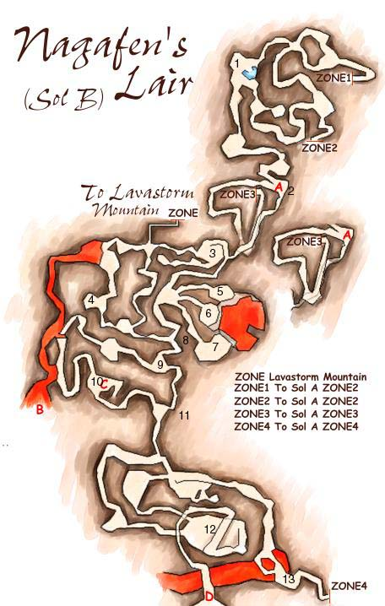
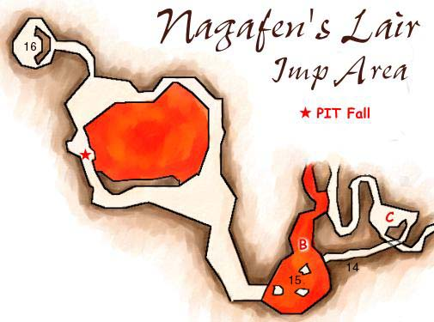
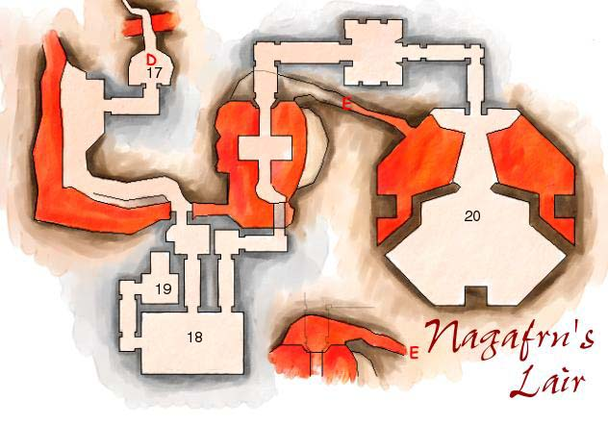
- Pool Room - This room is called the pool room, and is one of the main camping areas for gorups hunting kobolds for XP. It is a pretty good place to hunt because you have quite alot of spawns to yourself, they will always be GKs, and there are Sol A zones nearby to escape to. It's called the pool room because there is a small pool of water here, the only water in this entire dungeon.
- Window Room - This room is mostly a landmark, although occasionally people will hunt here (usually smaller groups). A good area to fight GKs.
- Circle Room - This room is called the circle room, and is a good room to hunt when soloing. There are two spawns in the room below, as well as spawns nearby. The zone to lavastorm is really close as well.
- Noble Room - This is where the Kobold Noble spawns, as well as two other kobolds. It's the first of the named monsters in Solusek B. The Noble is a level 38ish enchanter, and drops the Staff of Writhing (common), and the Petrified Erudite Heart Amulet (rare). Because he's an enchanter, he can easily turn the tide of the battle, so be careful.
- King Room - The Kobold King spawns here, a 40ish Shadowknight, as well as two other kobolds. Be careful fighting in any of these three rooms, since fighting close to the edge can accidentally draw kobolds from the other two rooms (Priest and Champion). Usually the group doing the king also does the Priest, and sometimes the Champion too. The King drops Runed Mithril Bracers (common) and Fleshripper (rare). Because Fleshripper is nodrop, sometimes lower level players hang out here and wait for an unclaimed FR. Occassionally, Targin the Rock spawns here as well, a 39ish monk. He drops the Code of Zan Fi, a quest item needed for the monk Robe of the Lost Circle quest.
- Priest Room - The Kobold Priest spawns in here, behind a secret door. You can also pull him from the king or champion room by casting or shooting at him. He's a 39ish cleric, and drops the Carnal Pauldrons (common) and the Mithril Breastplate (rare). See King Room (5) for warnings.
- Champion Room - The Kobold Champion is a 40ish warrior, and drops the Shield of the Slain Unicorn (common) and Painbringer (rare). Because Painbringer is nodrop, lower levels sometimes wait here to try to get one. Warnings from the King Room (5) apply to here as well.
- Crusher - The aptly named crusher is an important landmark in Sol B. It's a big block that moves up and down, and seperates the Kobold area from the Bats/Bugs. Most bats/bugs group choose to fight just past the crusher in (9).
- Crusher Room - This room is the first of the main camping spots for Bats/Bugs groups, and the one best suited to pulling the Noxious Spider and the Death Beetle. Two sonic bats spawn in here.
- Death Beetle Room - The Death Beetle spawns in here, as well as two other Lava Beetles. The Death Beetle is a 44ish scarab-looking beetle. He's probably the easiest of the named bugs. He drops the Black Chitten Leggings (common) and the Death Scarab Gland (rare). The beetle has a nasty disease based DoT which does about 900 damage over two minutes. Cure disease is useful against it. The scarab gland you get has one charge of Burrowning Scarab, which is the same DoT.
- Nox Corridor - The Noxious Spider is a wanderer that goes up and down this hall. He's a level 42 spider, looks like a jungle spider, and has a poison based DoT. He's pretty hard for his level. He drops the Green Silken Drape (common), and the coveted Gold Chittin Bracer (rare).
- Stone Spider Room - This large cavern room has a ramp leading up to the Fire Giant Castle. Most of the spawns in this room are LDCs, although occasionally one of the middle ones will be the Stone Spider. The Stone Spider is around level 45, and is almost completely immune to magic. This makes catching him when he runs away a real pain. He looks like a Desert Tarantula, and drops the Brown Chittin Protector, and the Crystalline Orb, a lame item with 5 charges of Eye of Zomm. It used to be that the BCP was the common drop, but I believe it is now the rare drop. Most groups camping the Stone Spider do it in this room itself.
- Bats Bugs Sol A Zone - This zone is one of the other popular places to pull bats and bugs to. It's got quite a few spawns in it (I believe a total of 4 bats), but it's got a very easy escape zone, you don't have to worry about other people's trains, and it's possible to pull the Stone Spider, Nox, and the Death Beetle all to this room. If there is no Stone Spider or crusher group, you can rack up alot of experience here. A wandering goblin named the "Guano Collector" very rarely spawns in place of the wandering bat here. The Guano Collector is around level 25. His common drop is the Soiled Bag, and his rare is the much sought after Cloak of Shadows.
- Lava Beetle Corridor - This corridor from the Death Beetle room down to the lily pads is called the lava beetle corridor. About 3 beetles spawn down its length. You should not pull from any farther than this room unless your group can handle imp protectors.
- Lily Pads - This area has three little stepping stones in the lava to jump across to get to the Efreeti area. It's like Super Mario Everquest. Crossing the lily pads will lead you to the very dangerous Efreeti area, where you can find Imp Protectors and Lava Guardians.
- Efreeti Room - The Efreeti Lord Djarn spawns here, about 40% of the time or so, on a 30 minute respawn. He is almost trivially easy for any group that can get to him. Getting to him is generally considered a two group ordeal, although it has been done with six good level 50 players. I've heard of it being done with just two Necros and two Clerics, but I'm positive that it's not safe to do it that way. Regardless, once you get there, only one group is required to hold the room, and I hear its a very boring camp. The hardest fight on the way will require you to take on at least three imp protectors, so be prepared. The lord himself drops the Golden Efreeti Boots (common), and the Djarn's Amethyst Ring (rare). One of the cases where the common drop is usually preferred.
- Fire Giant Castle Entrance - Past this point is the Fire Giant area.
- Throne Room - This large room is the spawn point of King Tranix, the king of the Fire Giants. He drops the Polished Mithril Torque (common) and the Crown of King Tranix (rare). He's red to a level 50, making him 53 or higher.
- Skarlon Room - This room is where Warlord Skarlong can be found. He is also 53+, and drops the Mithril Vambraces (common), the Mithril Greaves (rare), and the Razing Sword of Skarlon (very rare).
- Nagafen's Lair - Here is where Lord Nagafen, the red dragon may be found. Guarding him are a few Fire Giants, and well as Magi Rokyl, another Fire Giant. Rokyl is 53+, and drops the Polished Mithril Mask (common), and Rokyl's Channeling Crystal (rare). Nagafen himself is extremely difficult, and has a nasty AE fire attack, as well as an AE fear spell. He recovers hitpoints quick fast too. His drops are many, including: Bladestopper, Blight, Cloak of Flames, Dragon Tooth (casts the level 49 necro pet), Gauntlets of Fiery Might, Gold Plated Koshigatana, Heirophant's Crook, Orb of Tishan, Prayers of Life, Red Dragon Scale, and the Treasure Hunter's Satchel. The least people I've heard of taking on Nagafen since his last upgrade is 24.

Suggested Hunting
- 35-40 - The best place to hunt at these levels is the pool room, as you are guaranteed to be fighting all GKs. The window room and circle room are good alternatives. It's also possible to take on the noble room with ease, but the risk of charm along with the possible bad LDC pull make this a little dangerous. You can also do the King/Priest/Champ if you have a full group.
- 40-45 - The pool room will still give decent experience, but it's probably better to hit the named kobolds. The king room can be great xp and loot as long as sol b isn't too crowded. If you are feeling daring, do the bats and bugs, but probably stay away from double pulls of LDCs. Bats are great xp, and most GKs should still be blue.
- 45-50 - Some of the GKs will be green, so either do the King area and pull SKs and the occassional bat, or do bats and bugs. At the upper end, you'll probably find yourself doing the Efreeti Lord and the Fire Giants, but most likely not for experience. And of course, when you get a big enough group, take on the big boy, Nagafen himself.
Special Thanks to Parak and Coan Dragonclaw for their additional information for this guide. If you have any corrections or additions, please let me know.

