<Efreeti Lord|Relentless>

Overview
The Efreeti Lord run is one of the most challenging and fun runs for a 40+ group ready to test their mettle at a real adventure. It is almost always an extremely exciting run, and because of the way it is set up, there is added time pressure, forcing you to keep your downtime low and the pace up. Doing the efreeti lord is basically a two step process - Doing the run to get to the lord, and then camping the lord itself. Camping the lord is extremely boring, and is the main reason I don't like the run. The actual lord camp can be easily held with 6 people. The run itself is the fun part, and while it can be done with 6 people, I personally recommend having 12 people to keep things safe. If you choose to do the efreeti run the heavy handed way (Charging the groups of imps one at a time), you'll need a stronger party, but won't be nearly as pressed for time. This guide will be for doing the run with a feign death puller and killing one or two imps at a time.
The loot from the Efreeti Run mostly consists of the loot from the Efreeti Lord himself, although you might kill the Death Beetle and Guano Harvester in the early parts of the run. While the run is exciting, when you finally get to the Efreeti Room at the ending, be prepared for a big let down. His lair is just a boring, simple cave, and he's pretty easy to kill, making the climax anything but exciting.
The entire run take take about 30-48 minutes, usually broken into two segments, 24 minutes each. The Efreeti Lord spawns about 25-30% of the time, and his common drop is arguably better than his rare drop, so camping the lord is quite profitable from a loot standpoint. The spawn time on the lord is 24 minutes, and unless you are pulling for xp, you will only be killing 2 or 3 monsters every 24 minutes, so the camp is a very boring one.
The key to a successful Efreeti Run is timing. Someone in the group, probably the puller, must time the 24 minute spawn on the imps. Start timing from the first imp killed, and keep the timer running. If you miss your window of oppurtunity and let something respawn before your group has moved into position, you will get screwed over by backspawn and will end up fighting much more than you need to. Early on you'll feel that you have more than enough time and will probably get lax. Don't. Keep moving from the minute the first imp is killed, up until you reach the efreeti lord. Don't let your casters get to full mana. Make sure they know they will be fighting almost continuously, and should use mana sparingly. If a group's cleric is out of mana, have tanks in that group know to back off from the monster if they are getting hit. Casters should med every second that they aren't casting.

Monsters
There are two types of monsters you will be dealing with on the Efreeti Run, as well as some of the bats and bugs from the regular areas (Mostly Lava Beetles). Imp Protectors are more common, and there are also Lava Guardians.
- Imp Protectors - Range from level 44-48, hit for about 110, have quite a few hit points, and are one of the hardest "experience monsters" in the game. They have a fire-based proc, and a massive aggro radius.
- Lava Guardians - Range from level 44-46, hit for about 100. They are summoned creatures, and look like fire elementals. Have druids and magicians use anti-summoned spells against these. They also have a massive aggro radius. The more of these that are on the run, the easier that the run will be.

Chain Pulling
This second is copied from the Fire Giant guide I have, and is only here for reference.
The easiest and safest way to single pull Imps is to use chain pulling. If your puller hasn't had any practice with this method of pulling, it's suggested that you practice it in Lower Guk at the King and Lord camps. For those that don't know how to do this, here's a brief description:
There are at least two people involved in the pulling. The first, or primary puller, is a monk or shadowknight. The second, or chain puller, can be any tank class, although a monk or shadowknight is safest in case of an error. Any class with a good range attack can serve this role as well. He should be in the same group as the puller, should have his hitpoints buffed as well, and everyone should be set to assist the chain puller.
When all groups are ready for a pull, the primary puller goes out to the monsters, and aggros a group of them. He runs back towards the group, and when he's outside the aggro range of all of the monsters that are being pulled, he feigns death. At this point, the monsters that were pulled will hang around the feigned puller's body for awhile, and then start to go home. Hopefully, one of the group will linger around for longer than the others. When there is just one left, and the others have had enough time to get a good distane away from the lingerer, the chain puller comes up and smacks the last one, and runs it back to the group. If done properly, the others will be outside of aggro range and will not assist the single lingerer.
The primary puller stays on the ground till the fight has started, and then he can either lie there, or check to see if his aggro is clear. Only if he is certain that nothing is still aggro to him should he return to the group and help them out.
There are several variations to this, including multiple chainings and special casing wanderers and statics. These intracacies are not necessary, although it is suggested that your puller learn them in time. For Imps, you don't need to use any special tricks. Just make sure the puller knows when he has a wanderer on him, and not to return to the group unless he's sure that wanderer is no longer aggro.

Chain Pulling Doubles
Chain pulling doubles is very much like chain pulling singles. You use it when you know that your group can take two monsters at a time, and are pressed for time. Rather than trying to isolate a single, and sometimes attempting to chain twice or three times, you can just have your chain puller come in when there are still two monsters in aggro range. Both monsters will aggro to the chainer, and your group can handle them both. All other conditions for chain pulling apply.

Map and Breakdown of the Efreeti Lord Run
The best maps of Solusek B are (As usual) Quester of Norrath's. I've enlarged his Imp Area map and marked it up.
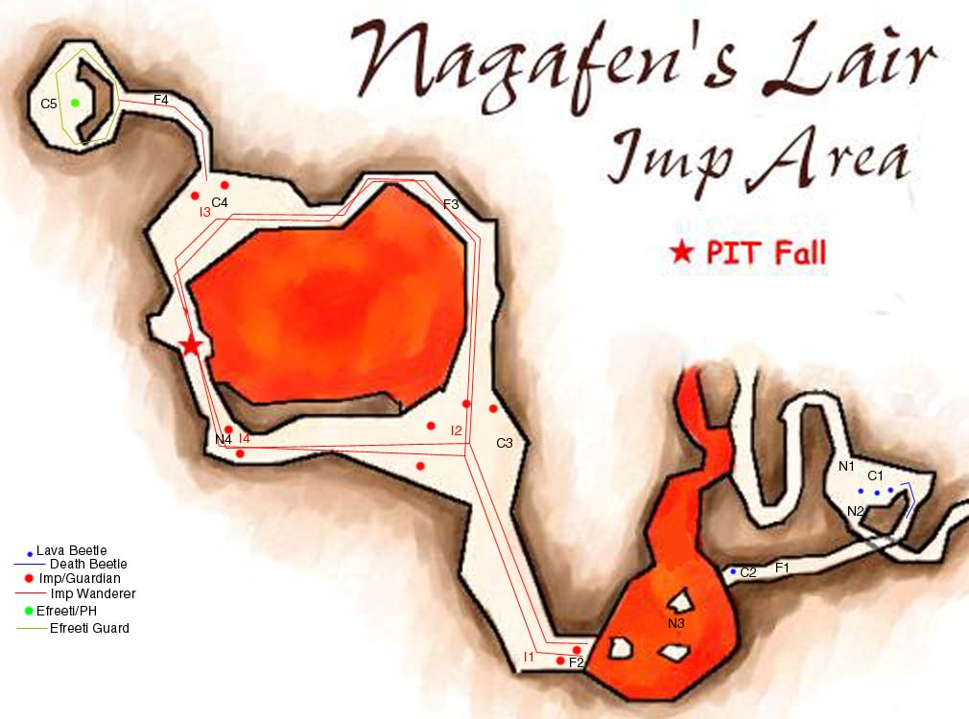
Legend
- Blue Lines - Wandering Lava Beetle/Death Beetle
- Blue Dots - Static Lava Beetle
- Red Lines - Wandering Imp Protectors/Lava Guardians
- Red Dots - Static Imp Protectors/Lava Guardians
- Green Dot - Efreeti Lord/Imp Protector
- Yellow Line - Wandering Imp Protector (Special Notes)
- Ixx - Imp Groups (referred to in the breakdown)
- Cxx - Camp Spots (where the main group will fight)
- Fxx - Feign Spots (where the primary puller will feign for pulls)
- Nxx - Notes
Beetle Room
The first thing your group needs to do is clear the Death Beetle room. This is the room marked C1 on the map. There are about 5 beetles that you need to kill total, including the one down the pathway. You can approach this room from either N1 or N2. We always come through N2, mostly because there's the rare chance that we might see the Guano Harvester. Hehe. Either way, you'll have to deal with a few bats. Should be no trouble if your group is ready to handle the Efreeti. Clear this room quickly, and have a secondary timer on the respawn of this room. It's not too important, as you are usually out of here before the respawn, but always good to be safe. Have everyone buff up and med to full. If your buffs drop in the middle of this run, you probably won't have a chance to rebuff (except the cheaper buffs). Once everyone is buffed, get ready for the pulls.
Imp Group 1
The party should all be at C1, and your puller should go across the lava, across the lily pads, and aggro one of the imps in I1. The puller can either have Dead Man Floating, Levitate, or just run quickly across. I prefer to just run across, since I like jumping alot when I pull, and you can't jump while levitating. The puller should feign at stop F1, and see how many imps/guardians are on him. If there are only two, you have the two statics, and can either chain pull them or kill them both off. If there are three, at least one is a wanderer, and if you got lucky, there are all four. It's best to kill the wanderers at the start of the cycle, so if you do have wanderers, let all the imps go home, then stand up. If things went well, the static imps should stay at I2, and any of the wanderers you had on you should come charging back. Take the wanderer(s) back to the group and kill them. The minute the first imp dies, start your timer.
It is almost always best to kill the wanderers first, but if you got the statics first, then you can have your puller wait at I1 until the wanderers come around, and pull them back to the group. This can take valuable time, and if you choose to, you can kill the wanderers whenever they show up. I'll assume they are killed at this point. Once all of I1 is dead as well as the wanderers, you might want to move the group up to C2. I usually choose to keep them at C1. Imps don't hit too hard, and pulling a longer distance for the sake of safety seems like a fair trade.
Imp Group 2
If things went well, you should have about 16-18 minutes left on your clock now. If you have more, you are doing well. If you have less, you need to hurry, and you'll definitely want to do the next set as fast as possible. Your group should be set up at C1 or C2, so that they are out of line of sight from the alcove across the lily pads. Your puller needs to go up the ramp, aggro the 3 or 4 imps at I2, and then run back down the ramp and feign at F2. If the puller wants, he can feign at F1 as well. I say 3 or 4, because while I usually see four imps up there, I think one of them is always one of the wanderers, and there are actually only 3 statics here. I always lose count, which is bad for a puller, but I'm sorry :). Either way, you can chain pull these easily, especially if your chain puller has a bow and can shoot the imps from across the lava river. After dispatching of these imps, it's time to move the group up to C3. By this point, all the wanderers need to be killed, and if there is just one left, have everyone kill it up at C3.
The Loop
When your party moves up to C3, make sure they do it properly. I usually ask for everyone to be levitating, cause someone invariably falls in the lava. If you do fall in the lava, it's not a big deal, it's easy to get out. Have everyone hug the right wall going up the ramp, and make sure the group stays near the right wall once they get up to C3. You can see I4 from this point, but they shouldn't aggro unless someone is fighting too far away from the walls. By now you should either have about 5-10 minutes left. If you have more than that, you are doing very well, and should be fine to continue moving forward. If you have that, or less than that, have your party rest up at C3 and wait for the wanderers to respawn and kill them. Only wait for the wanderers if you killed them in the first set of monsters. If I2 respawns before your group has moved, you will be in quite a bit of trouble. If you get really close to I2 respawning, and don't want to abort your run, have the group move to F3. F3 is generally a safe area. You won't be able to seperate the next group, but if you watch the wanderer carefully, you can charge the last group at I3, and only fight 2 at a time.
I'll assume you did this correctly, and don't need to charge the last group. Your group should be at C3. The wanderers respawn should be dead. Nothing should spawn on top of you for at least 5-8 minutes. The puller should aggro group I3, and feign at F3. If there are three monsters on him, one is a wanderer, and you can let them all go home, and then stand up to pull just the wanderer. If there are just two, you can pull them both to the group, or chain pull singles. After killing all of I3 except one, or after killing just one, leaving two, have your group move to F3, get ready, and charge whatever is left at I3. After killing I3, the hard part of the run is pretty much done, and you can relax quite a bit more. The party should all be at C4.
Final Approach
Have your puller go into the Efreeti area (C5), and aggro the room itself. Feign at F4 and chain pull a single. It's nice seperating the room a bit, which is why I choose to single pull these rather than charging the room. Once one of them is dead, have your group wait a short time, and then charge the last one in the efreeti room. You have now succesfully finished the Efreeti Run. Usually at this point, everyone leaves except six people, who gate out. Sometimes everyone will stay, but it's a boring camp, and people will leave. You can pull imps for experience, and they are very good experience. Just make sure you don't pull any big groups, and don't pull right before the room respawn. It's usually a good idea to keep I3 killed, in case of runners, and I usually don't touch I4, for reasons given in the notes. Enjoy your Golden Efreeti Boots and Djarn's Amethyst Rings. Djarn is a level 50 monster, and isn't hard for any group that managed to get here.
Notes
- N1 - Entering the Beetle Room through this path, you will encounter 6-7 bats from the crusher to here. It's got a little lava along the way, which is why I usually prefer not to take my party through it.
- N2 - This path will go past Nox's wandering path, as well as the Guano Harvester's path. There's a wandering bat that comes near here as well, which you might want to keep dead while you are in the room. (This bat is the placeholder for the Guano Harvester).
- N3 - This mario-esque jumping path of rocks across the lava river is called the "lily pads". You can run right across them with no trouble if you aim yourself right, or you can levitate across. Even if you are really clumsy, you shouldn't take more than 80-100 points of damage crossing the river.
- N4 - I've never attacked this group of imps. Even when I've gotten the entire loop cleared, I don't aggro these guys. The main reason for this is that even if you aggro them from the clockwise side, they will always pathfind counterclockwise, taking them past any of the imps at I3. Not worth the hassle in my opinion. I've never fallen in this pit either, and I'm not sure how to get out of the lava, but I'm sure there is a way. I'm not sure why you'd ever want to head through I4 to get to the Efreeti room, since it has more spawns to contend with.
Special Thanks to Parak and Coan Dragonclaw for their heads up to me on what to expect for my first run. Thanks to my guild, The Relentless, for allowing me to try this out for the first time with no idea what I was doing, and figure out what I needed to do. If you have any corrections or additions, please let me know.

